1.Webapi – odata ,authentication & authorization
Update rows
Depending on what you are trying to accomplish, you can choose between one of two methods for updating rows:
- If you're performing an update of multiple attribute values, use the HTTP PATCH method. PATCH methods provide upsert capability if you provide an ID value as part of your request, a beneficial feature when you're synchronizing data between systems.
- If you're updating a single attribute value, use the HTTP PUT method. You can't use this method with navigation properties like lookups because that requires a reference to be removed as well.
Note
POST vs PATCH in Dataverse
In Dataverse Web API, PATCH is used when you directly update fields on a record, such as changing the Opportunity Name or Estimated Revenue. However, POST is not used only for creating records. It is also used to execute Actions and Custom APIs that perform business operations with side effects. Therefore, you may see a POST request containing an existing Opportunity ID. In that case, the request is not creating a new Opportunity but executing an operation on the existing Opportunity, which may update its status or other data behind the scenes. A good rule for PL-400 is:
PATCH = Update record fields directly
POST = Create record OR Execute Action/Custom API
Show more lines
So, if an existing record ID is present and the method is POST, think "business operation", not necessarily "create record".
Provide your feedback on BizChat

Note: Why External Applications Use MSAL + HTTP (Web API) Instead of IOrganizationService
IOrganizationService is designed for code running inside Dataverse, such as Plugins and Custom Workflow Activities, where Dataverse has already authenticated the user and provides an authenticated service context automatically. External applications such as React, Node.js, Python, Java, or other non-.NET services run outside Dataverse and do not have access to this internal execution context. Therefore, they must first authenticate with Microsoft Entra ID using a library such as MSAL to obtain an access token, and then use HTTP/Web API calls to communicate with Dataverse. While .NET applications can simplify this by using ServiceClient (which internally uses authentication and Web API calls for you), non-.NET applications must use MSAL + HTTP/Web API directly because ServiceClient is a .NET-specific library.
Inside Dataverse
→ IOrganizationService
External .NET App
→ ServiceClient
→ (internally uses authentication + Web API)
External Non-.NET Ap
→ MSAL + HTTP/Web API
Show more lines
Interview One-Liner
External applications cannot use IOrganizationService because they execute outside the Dataverse runtime and do not receive an authenticated Dataverse execution context. They must authenticate through Microsoft Entra ID and access Dataverse using the Web API.

2. Impersonization
https://learn.microsoft.com/en-us/training/modules/dataverse-web-api/impersonate

3. Client script
1. Column dependency – It does not let remove field from the form
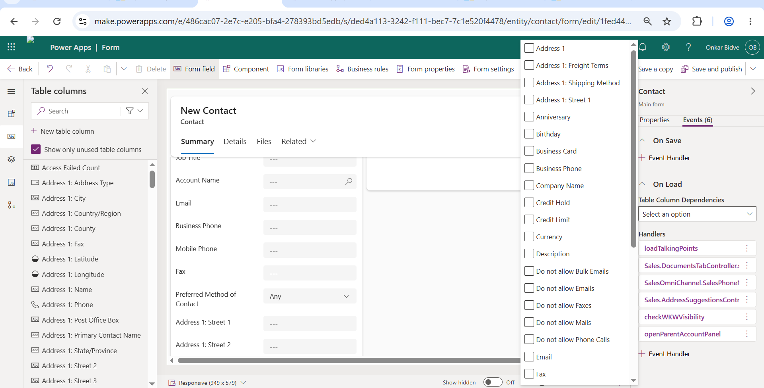
2.Web resource dependency
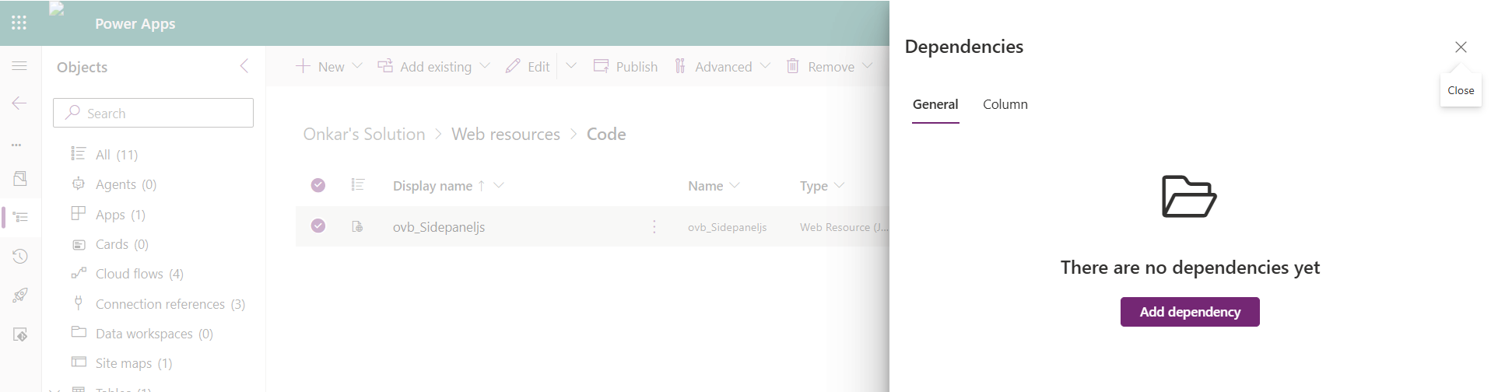

- Without Dependencies
Form
├── Utility.js
├── Account.js
└── Validation.js

- With Dependencies

Form
└── Account.js
── Utility.js
└── Validation.js
4. Event Handlers
One common pattern is registering an OnLoad handler and then registering the remaining event handlers via code in the OnLoad event handler logic. The benefit of this approach is that when you need your logic to run on multiple forms, you don't have to register all the event handlers on each form. Another advantage is if you need to dynamically determine some of the event handlers, you can use logic to decide whether to register a handler. For example, you may want to skip registering an event handler for a column if you can determine when the form is loaded and if this column is read-only or hidden.
- getEventSource- getEventSource() is a method available through the execution context. It returns the object that triggered the event.
- Nonentity data attribute - Data displayed through a Quick View Form or Business Process Flow fields. These values can appear on the form but do not belong to the current entity's attribute collection. For example, on a Contact form, Account information displayed through a Parent Account Quick View Form is not a Contact entity attribute.

5. OpenApi
Extension – .json

6. CORS
1.CORS is a browser-enforced security policy that applies to client-side requests such as JavaScript and PCF controls. It does not apply to server-side components like plugins, Azure Functions, console applications, or Power Automate, because those components do not execute within a web browser.
2. CORS is a browser security feature that prevents JavaScript running on one domain from calling APIs on another domain unless the API explicitly allows that origin. It mainly affects client-side JavaScript and does not typically affect plugins or server-side integrations.

7. App registrations - In most organizations, DEV, UAT, and PROD environments belong to the same Microsoft Entra ID tenant, so the same App Registration and Client ID can often be reused across environments. However, each environment typically has its own connection and connection reference. For stricter governance and security, some enterprises use separate App Registrations and secrets for each environment to isolate access and permission

